Final Project: Pick a Project
Computer Science - Week 10
Oct 3, 2026 - Version 0.0.2
Please make sure to your UD email AND name is below. Unless your UD emails are included in this table, then you will not earn any points for this assignment when it is graded! Every person should submit their own individual worksheet.

Talk about each of the questions with a friend or our LLM (or both), but make sure the words you enter below are yours (with the obvious exceptions notwithstanding). Brainstorming is best done in full sentences, and the main goal here is brainstorming. It's worth reviewing the information in this series of pages in the Drafter documentation to gain a better understanding of the process.

Role | Name | Email
Developer (You) | Henry Samer | hsamer@udel.edu
Friend (optional)

Part 1: The Goal & Prior Implementations
- Identify the Goal: What specific goal are you trying to address? Think about your passions, hobbies, and academic interests. The latter are an excellent candidate to focus on. Some majors have suggestions listed below: these were provided by faculty in those departments. Other majors could consider a focus tied to a big final assignment in one of their recent courses in their major.
  - Biomedical Engineering majors may consider one of the following:
    - If you have started (or completed) the Cell/Tissue Design final project in BMEG100, design an organoid, which involves combining a cell type, biomaterial, and testing method. Have the website include a description and diagram of your design concept, a testing method, a needs statement, and an impact statement relevant to their organoid. Also include a link to a paper that supports your idea and a paragraph describing how that paper supports your design concept.
    - Otherwise, create a website related to your BMEG100 Lab Report 1, Cytoskeletal and Nuclear Staining Lab Report Guidelines, linked here (University of Delaware account required to access).
  - Chemistry and Chemical Engineering majors may consider creating an automated chemistry assistant that takes balanced reaction equations, starting reactant masses, and a harvested product amount to determine the limiting reactant, theoretical yield, and percent yield based on principles from Chemistry 2e (OpenStax) — Chapter 4: Chemical Reactions and Stoichiometry. To avoid manually compiling atomic mass tables or writing custom string tokenizers, use the ChemPy library to parse molecular formulas into exact molecular weights and verify reaction stoichiometry against compound data from the NIH PubChem Database. The program outputs an organized breakdown of limiting reagent status, product yields, and remaining masses of unreacted species. Also use the heat of the reaction to determine if it is exothermic or endothermic, and compute the heat flow per mole of the product.
  - Majors in the Electric & Computer Engineering department may consider a steganography project that hides messages in images, and then retrieves those messages from uploaded images.
  - Mechanical Engineering majors may consider a project that somehow uses both the NumPy and SciPy Python libraries.
My goal that I am trying to solve is to create a project that helps individuals create a plan for ROTC/Army physical improvement.

- Prior Implementations: Search the internet. What existing tools or websites currently attempt to address it?
The website is fully free that helps give a plan for any type of fitness goals you have. Does not specifically give what recommended plan you should pursue. Helps with laying out your desired fitness plan but doesn't put it into a calendar. Problem is this works with more civilian or army people but not rotc including your already required training and then doing your own work.

- Your Implementation: Briefly describe the legitimate purpose or functionality of your site. How would you want this web application to be used?
I would want this application to be used where you originally start by putting in your data like your AFT Score then the morning PT plan that is already given and creates what your physical plan should be for the school year.

Part 2: The Input-Process-Output (IPO) Model
Think about the fundamental flow of your program.
- The Core Goal: Every program has three main phases: taking input, processing data, and presenting output. In one sentence, what is the ultimate goal your program will accomplish for the user? Be specific and use CS1 concepts.
The goal of my program will be to receive your aft scores and what your training plan already looks like, will then process the information for what you need to train and then it will output what your training plan should look like.

- Input: What specific information will the user need to provide to your program? (e.g., a city name, a numerical budget, a list of hobbies).
The input will need to be each aft score/or what you've gotten in each event. As well as what the plan is already for your program

- Processing: At a high level, how will the computer manipulate or evaluate that data? (e.g., calculate the average, filter out options that are too expensive, compare the input against a database).
The raw data of your marks on the AFT test will be turned into the specific score and then it will also check how far you are from maxing your test.

- Output: What will the user get back? (e.g., a recommendation, a calculated safety factor, a formatted schedule).
It will give you a calendar plan for how to max your score while also working in with your already planned out events.

Part 3: Data Abstraction
Identify the "nouns" of your problem.
- Representing Reality: Abstraction is the process of representing the real world inside a computer by ignoring unnecessary details. What are the core "things" (nouns) your program needs to track? (e.g., If building a recipe app, the nouns are "Recipe" and "Ingredient").
Track your scores, track your scheduled events

- Identifying Properties: For the most important "thing" you listed above, what 3 to 4 specific details do you actually need to solve your problem, and what details will you abstract away?
  - Details I need: (e.g., Ingredient name, weight, cost)
  - Details I will ignore: (e.g., Ingredient color, brand, expiration date)
I need Your scores, Your previous Weight, Gender, age
I will ignore Race, Location, Height, Eye Color

Part 4: Challenges, AI Strategy, & Goals
- Difficulties: What parts of this project seem the most difficult or technically complex?
The most difficult Part of the project will be creating the calendar in drafter. Somethink that has many blocks has never been discussed before so learning how to make a calendar will be very difficult.

- Coding Strategy: If you will be using an LLM to help code, how will you ensure you understand the generated code and avoid "hallucinations" or "shallow learning" (copying without understanding)? If you won't be using an LLM to help code, this project might take about 4 hours a week to complete, so list each of the days and times in which you work on the project.
I plan to look over each code and only use parts of the LLM to actually code the project. Leaning on the LLM for very mundane tasks where it would work incredibly fast but then only using the LLM to more explain the slightly difficult tasks where I can then work on it on my own.

- Goals: What is your ultimate goal for this project? (e.g., Impress the graders with a creative UI, build something I can use in my other classes, learn Drafter deeply).
The goal is to be able to have a website that will truly be a very good base of the goal. I don't expect a creative calendar or to reinvent the wheel, but to use what many of people have done like gritty soldier creating a website to calculate your aft score super simply as well as online sources that create and give you workouts on your own to then put everything together. Truly be able to use this program on my own

Part 5: Research & Brainstorming Conversation
Have a conversation with a Generative AI tool (like ChatGPT or Claude) OR a friend about your project idea. Do not ask for code. Instead, use the AI/friend as a sounding board to research your problem.
- The Initial Prompt/Question: Ask the AI or your friend to help you brainstorm. (e.g., "I want to build a simple web tool to help students track their study hours. What are 3 common problems students face when tracking their time, and what are 3 simple features a basic tool should have?"). Paste your prompt below:
3 parts- Calculate your aft score, training plan library and then training calendar

- The Response: Briefly summarize the best ideas the AI or your friend suggested. What existing solutions or prior apps did they mention?
They didn't really suggest new ideas but asked me to think about “Do you want the website to automatically generate a calendar from the cadet's scores and selected plan, or do you want cadets to manually arrange workouts on their calendar?” Which is actually something I was thinking about before because having the plan premade can simplify things on the entry level for users but for the whole group it is much more limited because they might already have their own plans.

- The Pushback: You must reply to the AI/friend to narrow the scope when it's over-ambitious. Pick the most complex feature they suggested and explain why it is too complicated for an introductory programming project. Ask them for a simpler alternative. Paste your response here:
That makes sense. Instead of building a whole training plan library, you could focus on guiding cadets toward improving their AFT scores using information they enter and a simple calendar.
Here are three simpler website features:
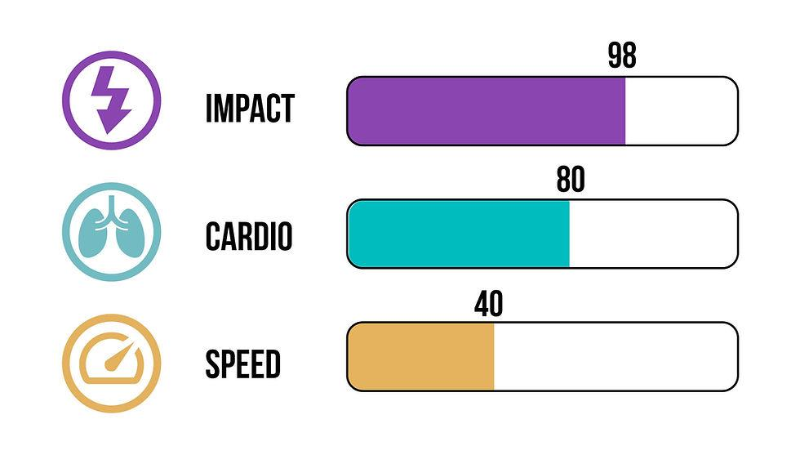
1. AFT Score Tracker
Cadets enter their current AFT scores and their goal scores. The website displays their progress and highlights which events they may need to focus on most.
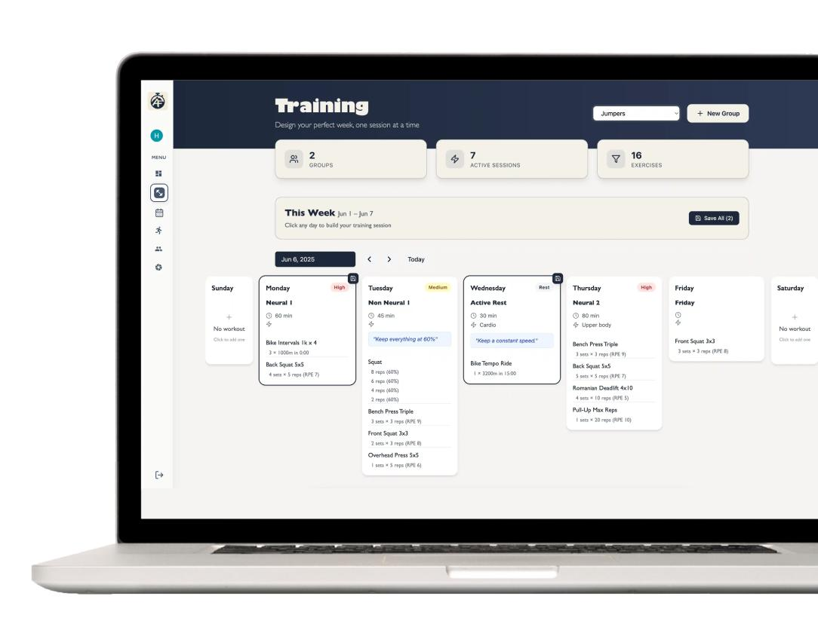
2. Personalized Training Calendar
Cadets add workouts to a weekly calendar based on their ROTC requirements, personal schedules, and fitness goals. They can check off completed workouts.
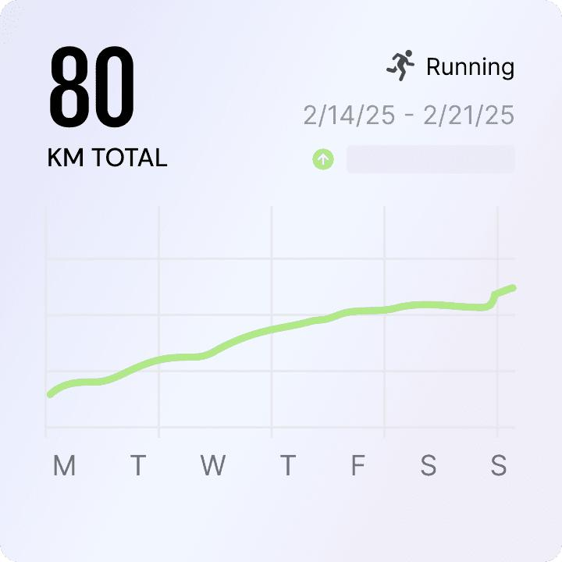
3. Progress and Guidance
The website tracks completed workouts and updated AFT scores, then provides simple suggestions, such as focusing on running endurance or strength. Suggestions should stay within approved ROTC guidance.
The main idea: Your website wouldn't need to create training plans. It would help cadets understand their scores, organize the workouts they already have to do, and track their improvement.
One question to help narrow the design: Do you want the website to recommend which workouts to focus on, or mainly help cadets organize workouts they already receive from ROTC

- Reflection: Based on this conversation, how has your project idea changed or become more focused?
It has become a lot more user initiated and less me choosing what would be best for them. That adds many layers of difficulty.

Part 6: Resource Planning
- What resources will you use if you get stuck?
I will go to office hours, drafter library, or Bakery AI for help

- If your LLM provides code that causes a Drafter or Bakery error, or if you run into a problem during deployment, what is your step-by-step debugging plan to resolve it?
I plan to comment out everything else and just work on that small part. Then I plan on using thoneys debugging tool to help me with seeing every step and then what I need to do to fix it if it is not acurrent. Also I will use assert equal in helping with this task.

Part 7: LLM Conversation
If you used an LLM in any part of this work, copy and paste every part of that conversation below. Otherwise, you may be given a zero for the assignment. Obviously, these words will not all be yours, and this is the exception to the requirement at the top of this assignment that all responses be in your own words. If you did not use an LLM to assist you in this assignment, simply say so below.
Replace this text with your answer.I have an idea about creating a website that will be able to recieve your aft scores along with peoples premaide training plans that is required through rotc and then give them the abikity to create a calendar that helps them work on improving the aft score. What are 3 simple eleents I should include in this website
I think your website idea has a clear purpose: helping ROTC cadets take their current Army Fitness Test (AFT) scores and required training plans and turn them into a personalized schedule for improvement.
If you want to keep the website simple for your first version, I would focus on these three core elements.
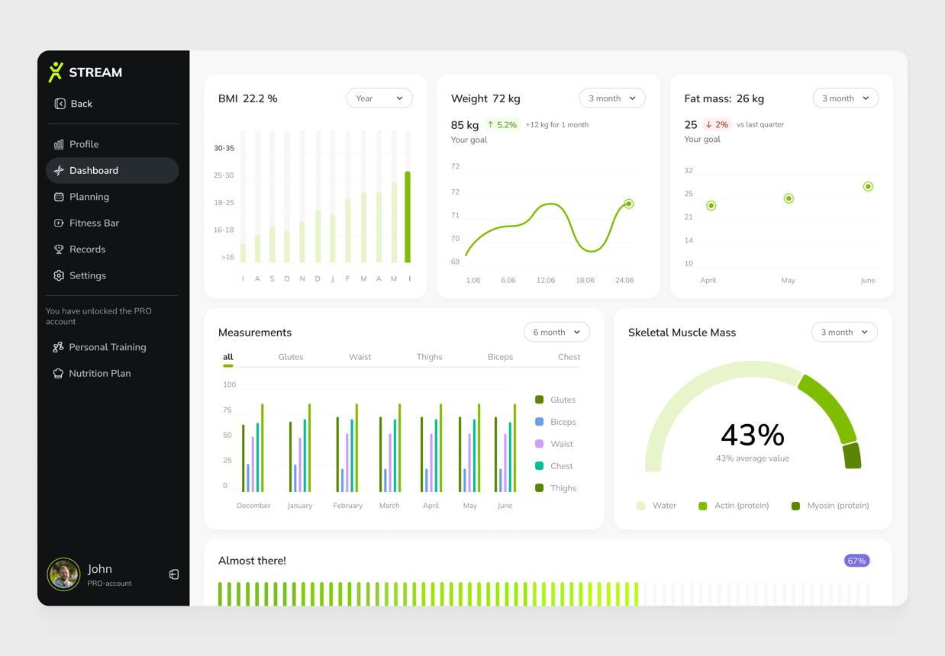

1. AFT Score Dashboard
Let cadets enter their current AFT event scores and track their progress over time.
- Input scores for each test event.
- Display current scores and personal goals.
- Show progress with simple charts or progress bars.
Why it matters: Cadets can identify which events need the most attention.
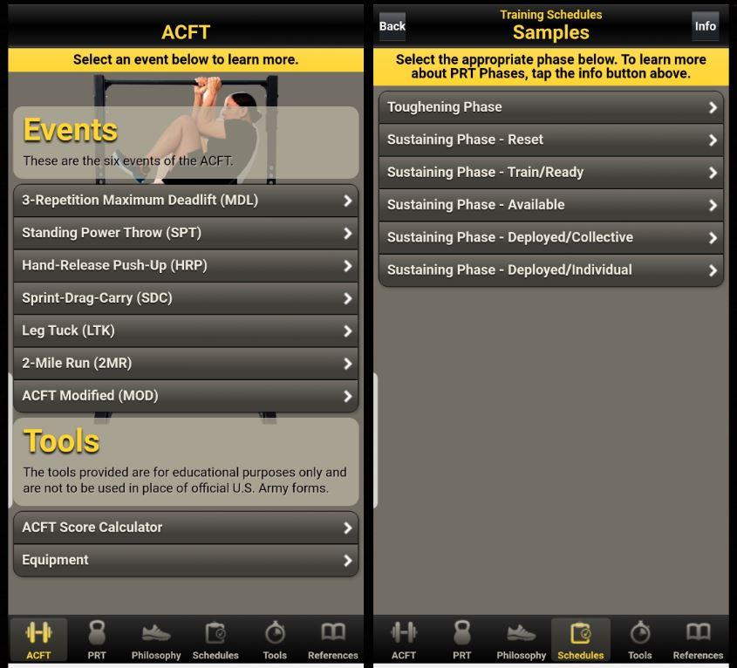

2. Training Plan Library
Provide a place where cadets can view and select pre-made ROTC training plans.
- Organize plans by training focus, such as running, strength, or endurance.
- Include the required ROTC workouts alongside optional supplemental training.
- Display workout instructions, duration, and difficulty.
Why it matters: Cadets have a clear starting point instead of having to build a training routine from scratch.
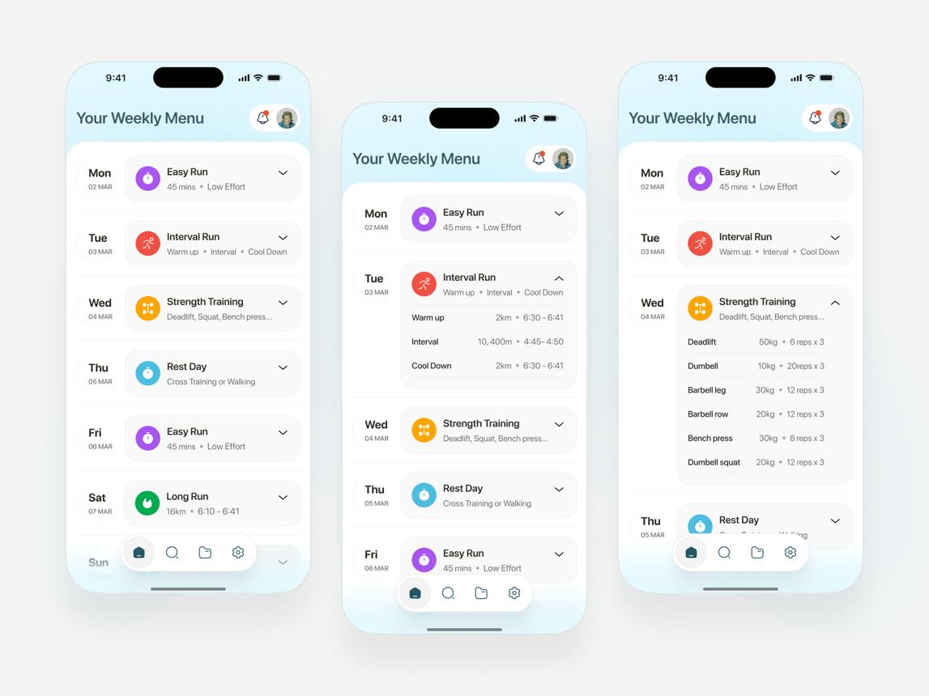

3. Personalized Training Calendar
Turn the selected training plan into a weekly calendar that cadets can follow.
- Schedule workouts around classes, ROTC obligations, and other commitments.
- Allow cadets to mark workouts as completed.
- Adjust upcoming workouts based on progress, recovery, and available time.
Why it matters: This is the feature that connects the scores and training plans into a practical daily routine.

How the three elements work together
1. Enter AFT scores
Identify strengths and areas for improvement
2. Select a training plan
Choose a plan that fits training needs and ROTC requirements
3. Generate a weekly calendar
Follow workouts, record completion, and monitor progress

My recommendation
Start with these three features before adding anything more complicated. The personalized training calendar should be the main feature that differentiates your website from a basic fitness tracker.
One important design consideration: make sure the training plans are consistent with current ROTC guidance, include appropriate recovery time, and do not automatically increase workout intensity just because a cadet has a lower score.
One question to help you shape the idea: Do you want the website to automatically generate a calendar from the cadet's scores and selected plan, or do you want cadets to manually arrange workouts on their calendar?
Convert to PDF
having a training plan library seems a little to embitius and not in the relm of giving more gudeince
That makes sense. Instead of building a whole training plan library, you could focus on guiding cadets toward improving their AFT scores using information they enter and a simple calendar.
Here are three simpler website features:
1. AFT Score Tracker
Cadets enter their current AFT scores and their goal scores. The website displays their progress and highlights which events they may need to focus on most.
2. Personalized Training Calendar
Cadets add workouts to a weekly calendar based on their ROTC requirements, personal schedules, and fitness goals. They can check off completed workouts.
3. Progress and Guidance
The website tracks completed workouts and updated AFT scores, then provides simple suggestions, such as focusing on running endurance or strength. Suggestions should stay within approved ROTC guidance.
The main idea: Your website wouldn't need to create training plans. It would help cadets understand their scores, organize the workouts they already have to do, and track their improvement.
One question to help narrow the design: Do you want the website to recommend which workouts to focus on, or mainly help cadets organize workouts they already receive from ROTC?

Part 8: Submit
In Google docs, with this document open, please click on File > Download > Microsoft Word (.docx), and make sure you put that download somewhere you can find it again. Then, upload it to the Canvas assignment about selecting or brainstorming your final project.

When you're done with this assignment, review this page of the Drafter documentation to better prepare for the next step.

